**All Writing Task 1 models**

**The pie chart shows the amount of money that a children's charity located in the USA spent and received in one year, 2016.**

Summarise the information by selecting and reporting the main features and make comparisons where relevant.

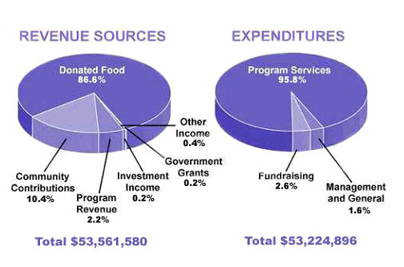

The pie charts show the amount of revenue and expenditures in 2016 for a children’s charity in the USA. Overall, it can be seen that donated food accounted for the majority of the income, while program services accounted for the most expenditure. Total revenue sources just exceeded outgoings.

In detail, donated food provided most of the revenue for the charity, at 86%. Similarly, with regard to expenditures, one category, program services, accounted for nearly all of the outgoings, at 95.8%.

The other categories were much smaller. Community contributions, which were the second largest revenue source, brought in 10.4% of overall income, and this was followed by program revenue, at 2.2%. Investment income, government grants, and other income were very small sources of revenue, accounting for only 0.8% combined.

There were only two other expenditure items, fundraising and management and general, accounting for 2.6% and 1.6% respectively. The total amount of income was $53,561,580, which was just enough to cover the expenditures of $53,224,896.

------------------------------------------------------------------------------------------------------------------

You should spend about 20 minutes on this task.

The table shows the Proportions of Pupils Attending Four Secondary School Types Between Between 2000 and 2009.

Summarise the information by selecting and reporting the main features and make comparisons where relevant.

|  |  |  |  |
| --- | --- | --- | --- |
|  | **2000** | **2005** | **2009** |
| **Specialist Schools** | 12% | 11% | 10% |
| **Grammar Schools** | 24% | 19% | 12% |
| **Voluntary-controlled  Schools** | 52% | 38% | 20% |
| **Community Schools** | 12% | 32% | 58% |

The table illustrates the percentage of school children attending four different types of secondary school from 2000 to 2009. It is evident that whereas the community schools experienced a marked increase in the proportion of those attending their institutions over the period, the others saw a corresponding decline.

To begin, the percentage of pupils in voluntary-controlled schools fell from just over half to only 20% or one fifth from 2000 to 2009. Similarly, the relative number of children in grammar schools - just under one quarter - dropped by half in the same period. As for the specialist schools, the relatively small percentage of pupils attending this type of school (12%) also fell, although not significantly.

However, while the other three types of school declined in importance, the opposite was true in the case of community schools. In fact, whereas only a small minority of 12% were educated in these schools in 2000, this figure increased to well over half of all pupils during the following nine years.

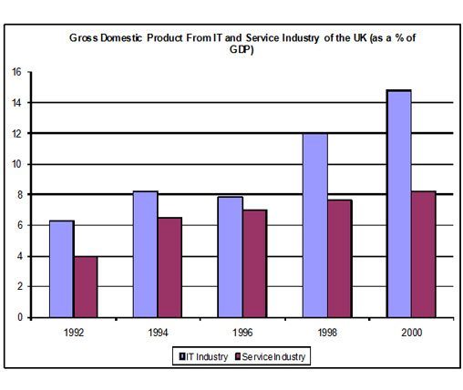

The chart shows components of GDP in the UK from 1992 to 2000.

Summarize the information by selecting and reporting the main features and make comparisons where relevant.

The bar chart illustrates the gross domestic product generated from the IT and Service Industry in the UK from 1992 to 2000. It is measured in percentages. Overall, it can be seen that both increased as a percentage of GDP, but IT remained at a higher rate throughout this time.

At the beginning of the period, in 1992, the Service Industry accounted for 4 per cent of GDP, whereas IT exceeded this, at just over 6 per cent. Over the next four years, the levels became more similar, with both components standing between 6 and just over 8 per cent. IT was still higher overall, though it dropped slightly from 1994 to 1996.

However, over the following four years, the patterns of the two components were noticeably different. The percentage of GDP from IT increased quite sharply to 12 in 1998 and then nearly 15 in 2000, while the Service Industry stayed nearly the same, increasing to only 8 per cent.

At the end of the period, the percentage of GDP from IT was almost twice that of the Service Industry.

-------------------------------------------------------------------------------------------------------------------

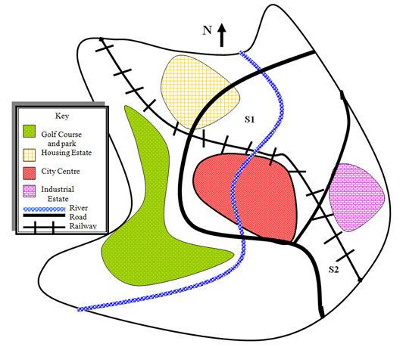

The map illustrates plans for two possible sites for a shopping mall in the city of Brandfield. It can be seen that the two sites under consideration are in the north and the south east of the town.

The first possible site for the shopping mall, S1, is just north of the city centre, above the railway line, which runs from the south east of the city to the north west. If it is built here, it will be next to a large housing estate, thus providing easy access for those living on the estate and in the city centre. It will also be next to the river that runs through the town.

The site in the south east, S2, is again just by the railway line and fairly close to the city centre, but it is near to an industrial estate rather than housing.

There is a main road that runs through the city and is close to both sites, thus providing good road access to either location. A large golf course and park in the west of the town prevents this area from being available as a site.

Below is a map of the city of Brandfield. City planners have decided to build a new shopping mall for the area, and two sites, S1 and S2 have been proposed.

Summarise the information by selecting and reporting the main features and make comparisons where relevant.